Framing for Interviewer:
We want to thank you [Applicant name] for being here and your interest in serving our district’s students. I’m going to begin by framing the purpose of the interview and then we will do introductions. The purpose of this interview is to clarify the district’s understanding of your application and to assess the capacity of the founding team by asking both clarifying and probing questions, which are aligned to core components of the new school application and developed by the district’s charter application review team members. Clarifying questions will focus on factual clarification of the application, and should only require a brief response (i.e. yes/no or short answer). Probing questions are intended to gain greater clarity around an aspect of the application that is unclear or needs further explanation. We will indicate which type of question we are asking.
Most of our questions are directed towards the founding team, so please feel free for members of your team to answer as you see fit. We also may direct specific questions to certain members of the team, including the board. We have X questions, some of them lengthy, to get through in just under an hour. That’s about X-X minutes a question, so we ask that you try to be succinct in your response; we may also gently stop you if we feel you have answered the question or gone in a different direction. All interviews are recorded and the video will be shared with the other members of the charter application review team who will meet again this week. Of our 90 minutes today, we will be sharing our time today with the DAC. We will have just under an hour of questions and the DAC will have the remaining time to ask questions. After the interview portion, we’ll spend a few minutes reviewing next steps of the process. Let’s start with introductions.
Next Steps:
- We will share this recording with the application review team, who will consider your responses against the district’s criteria and share this information with the Superintendent.
- The Superintendent will share his written recommendation to the board of education prior to the (Insert Date) Work Session, as will the DAC. We will contact you to share this recommendation ahead of the (Insert Date) meeting as well.
- In alignment with policy governance, the Board will not be requesting presentations from applicants at this meeting.
- We invite you to bring out your supporters on (Insert Date) for Public Comment. The process will culminate in a board vote the same night to approve or deny the application.
- Do you have any questions about the process?

Interview Questions:
Application Name
Date of Interview
Interviewees
Interviewers

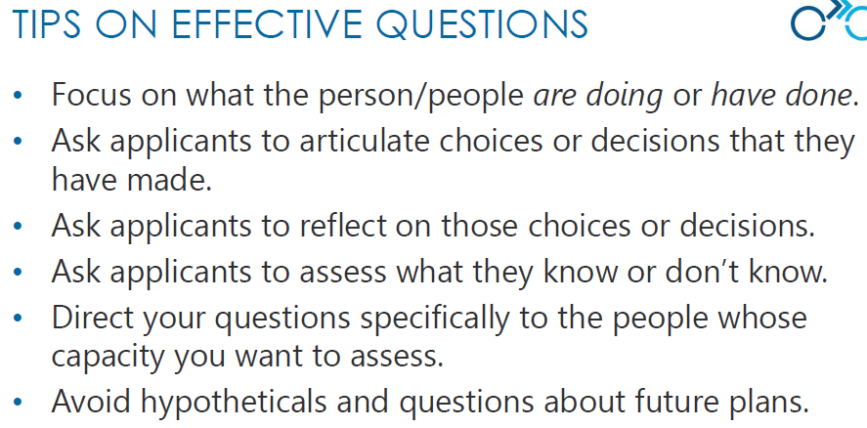

STANDARD QUESTIONS
Start with the standard interview questions, then go through the application review team’s school-specific clarifying questions, then probing questions.
Question | Directed at | Section of Application | Standard Questions | Interviewer Notes | Addressed Concern?
 | Open | School Culture/ Summary | Describe the vision and mission of your proposed school and the specific need that this school would meet. |  | - Yes, answer clarified  - No, still unclear  - Red flag - Significant concern
 | School Leadership Team | Leadership - Capacity | What in your proposed leadership team’s background and experience has prepared you to launch and lead a successful new school, and what steps have you taken to address capacities that your team may be lacking?  - Possible Follow-Up (if clear gaps in leadership capacity):  If leader/leadership team not identified: Knowing that your proposed school has not yet identified a leader or leadership team, what steps have you taken in the interim to provide the capacity necessary to successfully launch a new school?  - Follow-Up: How will you ensure a new leader has the capacity to take on the work of leading a new school? |  | - Yes, answer clarified  - No, still unclear  - Red flag - Significant concern
 | Board | Governance - Capacity | What are the most essential roles and responsibilities of the board in overseeing this school prior to opening and once it’s operating, and what in your background and experience prepares you to provide that?  - (Listen for: specifics on academic, operational, and financial oversight)  - Possible Follow-Up (if clear gaps in board capacity): |  | - Yes, answer clarified  - No, still unclear  - Red flag - Significant concern

SCHOOL SPECIFIC QUESTIONS
First, write down all clarifying questions, then develop probing questions.

Question | Directed at | Section of Application | Standard Questions | Interviewer Notes | Addressed Concern?
- Yes, answer clarified
- No, still unclear
- Red flag - Significant concern
- Yes, answer clarified
- No, still unclear
- Red flag - Significant concern
- Yes, answer clarified
- No, still unclear
- Red flag - Significant concern
- Yes, answer clarified
- No, still unclear
- Red flag - Significant concern
- Yes, answer clarified
- No, still unclear
- Red flag - Significant concern
- Yes, answer clarified
- No, still unclear
- Red flag - Significant concern
- Yes, answer clarified
- No, still unclear
- Red flag - Significant concern

