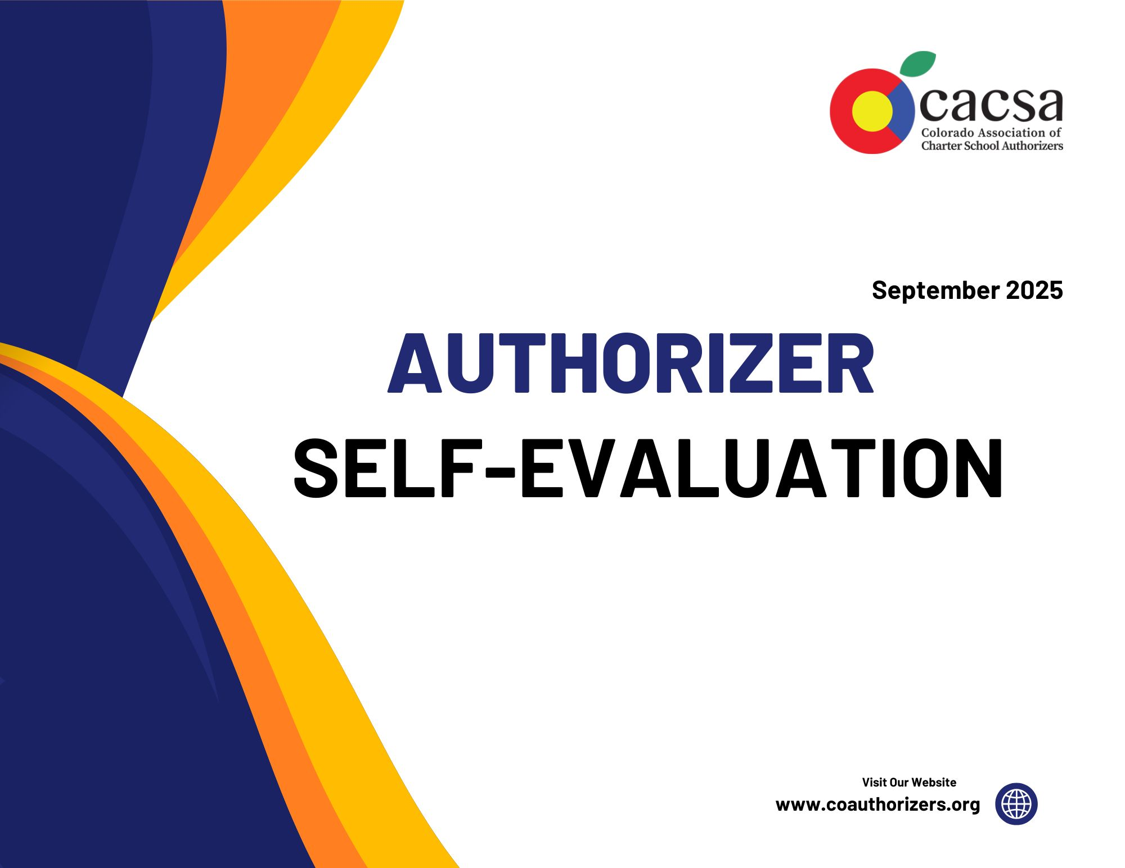
Colorado Charter School Authorizer Self-Evaluation Tool
Published: September 2025

Purpose
This self-evaluation tool is designed to help Colorado charter school authorizers assess their practices against both NACSA’s Principles & Standards and the Colorado State Authorizer Standards (1 CCR 301-88). NACSA’s Principles & Standards are the nationally recognized benchmark for quality charter school authorizing, developed through two decades of research, field input, and consensus across the authorizing community. They articulate five core domains that define essential practices of effective authorizing:
- Agency Commitment & Capacity
- Application Process & Decision-Making
- Performance Contracting
- Ongoing Oversight & Evaluation
- Revocation & Renewal

The Colorado Department of Education developed the Colorado Authorizer Standards in collaboration with CACSA and authorizers across the state. They are codified in rule and ensure alignment to both state statutory requirements and national best practices. By integrating the Colorado standards with NACSA’s framework, this tool provides authorizers with a comprehensive reflection and improvement resource that is both nationally grounded and locally tailored.

Instructions for Use
Step 1. Rate Your Authorizing Practices
For each indicator in every domain, assign one of the following point values:
- Established (1 point): Fully meets the expectation.
- Partially Established (0.5 points): In progress but not consistent.
- Not Established (0 points): No evidence or practice in place.
Step 2. Document Evidence
Identify and collect supporting materials (e.g., policies, contracts, reports, board minutes, artifacts) that justify the rating given for each indicator.
Step 3. Complete the Summary Dashboard
After scoring all indicators in a domain, total the points earned and enter the score in the dashboard. Then, as a group, identify and record the Top Strengths and Top Areas for Improvement for each domain.
Step 4. Reflect as a Team
Use the reflective prompts provided in each section to guide discussion. Involve multiple departments (finance, legal, curriculum, special education, etc.) so that the evidence is comprehensive and perspectives are diverse.
Step 5. Plan Improvements
Review the suggested next steps included in this document. As a team, prioritize the areas needing attention and set measurable goals for the next cycle.
Who Completes This
The tool should be completed collaboratively by authorizing staff. In districts without a dedicated authorizing office, the superintendent or a designee may lead. Other district staff who work with charter schools should be included as appropriate. The lead authorizing staff member or designee is responsible for facilitating evidence collection and reflection sessions.
Scoring and Use
- Each indicator is rated individually using the point scale (1 / 0.5 / 0).
- Domain scores are totals that provide a snapshot of current practice.
- There are no “right” or “wrong” answers or scores. The purpose is to use the tool over time to track improvement, guide conversations, and build shared accountability.
CACSA provides resources, coaching, and convenings to support this work. Authorizers are encouraged to complete the tool annually and use the results to measure growth and inform planning.
Authorizers should allocate approximately 60–90 minutes to complete this exercise if being done individually, or up to 2-3 hours for a collaborative team-based review. If facilitating a meeting, it is recommended that participants receive the tool in advance and complete an initial draft independently or in departmental teams before convening. This allows meeting time to focus on discussion, calibration, and action planning.
CACSA is available to facilitate or co-facilitate self-evaluation sessions, provide feedback, and help identify areas for deeper reflection or improvement prior to submission. We encourage authorizers to reach out if they would like additional support designing or guiding this process.

Domain A: Agency Commitment & Capacity (CO 3.02)
Indicator | Colorado Standard Reference / NACSA # | Rating | Evidence Examples | Reflective Prompts
The authorizer states a clear mission for quality authorizing. | 3.02(A)(6)  NACSA #1-Agency Commitment & Capacity | Please select | Board-approved mission statement; authorizing vision section of strategic plan. | How visible is our mission? Do staff/board use it in decision-making?
Has a strategic vision and plan with goals, priorities, and timelines. | 3.02(A)(7)  NACSA #1-Agency Commitment & Capacity | Please select | Strategic plan with timelines, annual updates. | Do we measure progress toward strategic authorizing goals annually?
Provides an annual public report on the authorizer's progress and performance. | 3.02(A)(9)  NACSA #4-Ongoing Oversight & Evaluation | Please select | Annual published authorizer performance report. | How transparent are we about our own effectiveness as an authorizer?
Protects functions from conflicts of interest and political influence. | 3.02(A)(3)  NACSA #1-Agency Commitment & Capacity | Please select | Conflict of interest policies, recusal documentation. | Where are our greatest risks of conflict? How do we safeguard independence?
Dedicates sufficient human resources with expertise in law, finance, curriculum, special education, and governance. | 3.02(B)(1)–(2)  NACSA #1-Agency Commitment & Capacity | Please select | Staff resumes, contracts with finance/legal/special education experts. | Do we have the right expertise internally or through contracts?
Provides regular professional development for authorizing staff. | 3.02(B)(3) | Please select | PD agendas, NACSA conference participation, and evaluator training. | How do we keep staff current with evolving practices?
Reviews conflict of interest, compensation compliance, and oversight processes. | 3.02(B)(4)  NACSA #4-Ongoing Oversight & Evaluation | Please select | Oversight reports, monitoring checklists. | How do we monitor compliance in our portfolio?
Secures and deploys sufficient financial resources. | 3.02(C)(1)–(3)  NACSA #1-Agency Commitment & Capacity | Please select | Budget documents, indirect cost allocation. | Does our budget align with portfolio size and workload?
Requires each school to conduct annual independent financial audits. | 3.02(C)(4)  NACSA #4-Ongoing Oversight & Evaluation | Please select | School audits, corrective action follow-up reports. | How do we ensure audit findings inform oversight?

Domain B: Application Process & Decision-Making (CO 3.03)
Indicator | Colorado Standard Reference / NACSA # | Rating | Evidence Examples | Reflective Prompts
Issues comprehensive RFP stating priorities, guidance, evaluation criteria. | 3.03(A)(1)  NACSA #2-Application Process & Decision Making | Please select | Public-facing applications, processes, timelines, and rubrics - charter website. | Are application materials clear and transparent for all applicants?
Welcomes first-time applicants and replicators with distinct criteria. | 3.03(A)(2),(C)(2)  NACSA #2-Application Process & Decision Making | Please select | Public-facing applications, processes, timelines, and rubrics - charter website. | How do we distinguish criteria for new vs. replication proposals?
Has a process to evaluate the expansion and replication of successful schools. | 3.03(A)(3)  NACSA #2-Application Process & Decision Making | Please select | Replication processes, a clear outline of what is expansion, replication, relocation, or significant modification. | Do we incentivize proven quality?
Open to diverse educational philosophies and models. | 3.03(A)(4)  NACSA #2-Application Process & Decision Making | Please select | Community input, review teams. | Are we equitable in reviewing alternative models?
The application process is open, well-publicized, transparent, and has realistic timelines. | 3.03(B)(1)  NACSA #2-Application  Process & Decision Making | Please select | Public-facing applications, processes, timelines, and rubrics - charter website. | Do applicants and community members know our process?
Provides sufficient time for each stage of the process. | 3.03(B)(2)  NACSA Standard #2-Application Process & Decision Making | Please select | Public-facing applications, processes, timelines, and rubrics - charter website. | Are timelines realistic for applicants and evaluators?
Rigorous evaluation includes review, interviews, and due diligence. | 3.03(D)(2)  NACSA Standard #2-Application Process & Decision Making | Please select | Capacity interviews, multiple rounds of review, and various reviewer perspectives. | Do we use trained evaluators with expertise in law, finance, and academics?
Provides training for application evaluators. | 3.03(D)(4)  NACSA Standard #2-Application Process & Decision Making | Please select | Training session materials. | How do we ensure evaluator consistency and fairness?
Ensures decision-making free of conflicts of interest. | 3.03(D)(5)  NACSA Standard #2-Application Process & Decision Making | Please select | Training session materials covering conflict of interest. | What safeguards ensure impartiality?

Domain C: Performance Contracting (CO 3.04)
Indicator | Colorado Standard Reference / NACSA # | Rating | Evidence Examples | Reflective Prompts
Executes contracts with independent governing boards. | 3.04(A)(1)  NACSA Standard #3-Performance Contracting | Please select | Contracts should be posted after board approval. | Are our contracts legally binding and separate from the application?
Contracts define rights, autonomies, and responsibilities. | 3.04(B)(1)  NACSA Standard #3-Performance Contracting | Please select | Reflection on statutory language. Differentiate between district/state requirements. | Do contracts clearly articulate autonomy in staffing, budgeting, and curriculum?
Contracts define measurable academic, financial, operational, and performance standards. | 3.04(C)(1)–(2)  NACSA Standard #3-Performance Contracting | Please select | Alignment to statute, Ed program, etc. | Are renewal standards clearly linked to contract terms?
Contracts define evidence sources for evaluation (assessments, audits, reviews). | 3.04(C)(3)  NACSA Standard #3-Performance Contracting | Please select | Consistent contracting language across schools. | Are evidence sources comprehensive and reliable?
Contracts state obligations regarding equitable access and services. | 3.04(B)(1)(f)  NACSA Standard #3-Performance Contracting | Please select | No co-mingling of language, appropriate departments looking at different aspects. | Do contracts ensure compliance with IDEA, Section 504, and ELL requirements?
Service agreements are separate and not conditions of approval/renewal. | 3.04(B)(2)  NACSA Standard #3-Performance Contracting | Please select | Reference to the third-party agreement in the contract. | Do we separate accountability from optional services?
Contracts with third-party providers include independent oversight provisions. | 3.04(D)(1)–(3)  NACSA Standard #3-Performance Contracting | Please select | Is there a management contract? | Do we review and enforce management agreements effectively?

Domain D: Ongoing Oversight & Evaluation (CO 3.05)
Indicator | Colorado Standard Reference / NACSA # | Rating | Evidence Examples | Reflective Prompts
Implements comprehensive accountability and compliance monitoring. | 3.05(A)(1)  NACSA Standard #4-Ongoing Oversight & Evaluation | Please select | Reportwell (reporting platform), shared timeline, checklists, etc. | How streamlined is our monitoring system?
Defines and communicates methods/timing of reporting. | 3.05(A)(2)  NACSA Standard #4-Ongoing Oversight & Evaluation | Please select | Reportwell (reporting platform), shared timeline, checklists, contracts, etc. | Do schools understand our reporting expectations?
Streamlines federal, state, and local compliance requirements to minimize burden. | 3.05(A)(3)  NACSA Standard #4-Ongoing Oversight & Evaluation | Please select | No duplicate submissions, streamlined distribution. | Are we balancing compliance with autonomy?
Conducts school visits only as necessary, respecting autonomy. | 3.05(A)(4)  NACSA Standard #4-Ongoing Oversight & Evaluation | Please select | Collaboration - purpose of visit, transparency. | Are our visits purposeful and non-intrusive?
Provides annual written performance and compliance reports. | 3.05(A)(7)  NACSA Standard #4-Ongoing Oversight & Evaluation | Please select | Finalized reports. | Do our annual reports provide actionable feedback?
Produces an annual public report on portfolio performance. | 3.05(E)  NACSA Standard #4-Ongoing Oversight & Evaluation | Please select | Public reports and/or board presentations. | How do we share results with stakeholders?
Oversight protects student rights in admissions, discipline, and access to services. | 3.05(C)(1)–(4)  NACSA Standard #4-Ongoing Oversight & Evaluation | Please select | Required training, policy reviews, data checks, and reporting. | Do our practices safeguard equity and access?
Clear, timely intervention policy exists and is implemented. | 3.05(D)(1)–(4)  NACSA Standard #4-Ongoing Oversight & Evaluation | Please select | Policy, contract, handbook guidelines. | Do schools view our interventions as fair, transparent, and effective?

Domain E: Revocation & Renewal Decision-Making (CO 3.06)
Indicator | Colorado Standard Reference / NACSA # | Rating | Evidence Examples | Reflective Prompts
Renewal decisions based on comprehensive academic, financial, and operational evidence. | 3.06(B)(1)  NACSA Standard #5-Revocation & Renewal Decision Making | Please select | SPF, renewal application, school budgets and audits, notices or breaches, site visit trends, monitoring body of evidence, organizational compliance, strategic plan. | Do we weigh academic achievement most heavily, as required?
Grants renewal only to schools that are viable and faithful to contract/law. | 3.06(B)(2)  NACSA Standard #5-Revocation & Renewal Decision Making | Please select | OCR complaints, notices or breaches, financial audits, DOJ, compliance records, action plan progress, federal vs. state accountability clock. | Do we ever renew based on pressure vs. evidence?
Provides cumulative performance reports prior to renewal. | 3.06(C)(1)  NACSA Standard #5-Revocation & Renewal Decision Making | Please select | Site visit report, SPF distribution, office hour minutes and attendance, UIP goal progress, strategic plan, presentation dates. | How thorough and timely are our reports?
Renewal applications allow schools to respond and provide evidence. | 3.06(C)(2)  NACSA Standard #5-Revocation & Renewal Decision Making | Please select | Application with a rubric, guiding questions, list of required items, public record minutes, interview, board agendas, school presentations to board, written responses. | Do schools have a meaningful opportunity to present their case?
Clearly communicates criteria for renewal/revocation and updates processes. | 3.06(D)(1),(5)  NACSA Standard #5-Revocation & Renewal Decision Making | Please select | Board policy regarding charter schools, policy posted, written processes, rubrics, application with guiding questions, rubrics, timelines, charter contracts, board minutes, standard questions required, reviewer norms. | Is our process public and consistently applied?
Provides timely public notification of decisions. | 3.06(D)(3)  NACSA Standard #5-Revocation & Renewal Decision Making | Please select | Closure process with timelines, statute timelines, written procedures, public announcements, posted board minutes, enrollment/school choice policies. | Do families have enough time to make choices?
Explains rights of appeal in writing. | 3.06(D)(4)  NACSA Standard #5-Revocation & Renewal Decision Making | Please select | Contracts, board policy, assurances, board minutes. | Do schools understand their appeal rights?
Closure protocols ensure student transitions and lawful disposition of assets. | 3.06(E)  NACSA Standard #5-Revocation & Renewal Decision Making | Please select | Closure process documents. | Do we have a tested plan for orderly school closures?

Summary Dashboard
The table below provides a way to summarize scores across each domain. Each indicator is scored using the point system (1, 0.5, 0). The total possible points for each domain are shown in the “Overall Score” column.

Authorizing teams can use the Summary Dashboard as both a snapshot and a planning tool. After completing the “Overall Score” for each domain, the team records the total score in the dashboard and then discusses the accompanying “Top Strengths” and “Top Areas for Improvement.” This process encourages collaborative reflection, allows different perspectives (e.g., finance, legal, academic, special education) to be heard, and creates a shared record of progress. Over time, teams can compare scores from year to year to see where capacity has grown and where attention is still needed, making the dashboard a practical anchor for continuous improvement conversations.

This dashboard is not intended to establish a “right” or “wrong” score. Instead, it serves as a tool for teams to reflect on their current practices, identify strengths and areas for improvement, and track progress over time. By revisiting this self-evaluation annually, authorizers can measure growth, celebrate improvements, and prioritize next steps for continued development.

Domain | Overall Score | Top Strengths | Top Areas for Improvement
A. Agency Commitment & Capacity | __/9
B. Application Process & Decision-Making | __/9
C. Performance Contracting | __/7
D. Ongoing Oversight & Evaluation | __/8
E. Revocation & Renewal | __/8

Guidance for Next Steps Based on Your Summary Dashboard
After completing ratings across Domains A–E, use the following guidance to determine next steps. For each domain, authorizers should reflect on areas to consider for growth, take immediate actions to strengthen practice, and draw on resources available through CACSA.

Domain A: Agency Commitment & Capacity
- Areas to Consider for Growth: Mission clarity and visibility; strategic planning with measurable goals; public transparency in reporting; safeguards against conflicts of interest; adequacy of staffing and expertise across key functions; regular PD for authorizing staff; financial resource allocation aligned to portfolio size and needs.
- Immediate Actions: Review and update mission and vision to ensure alignment with quality authorizing principles; revise or refresh the strategic plan to include timelines and measurable targets; publish an annual performance report for the authorizer; conduct a conflict-of-interest review; assess internal capacity and secure needed legal, financial, and SPED expertise; implement a PD calendar for authorizing roles.
- Resources Available:
  - Colorado Charter Authorizer Standards

Domain B: Application Process & Decision-Making
- Areas to Consider for Growth: Clarity and transparency of application materials and timelines; differentiated criteria for first-time vs. replication proposals; consistent evaluator training and use of rigorous, multi-stage review processes; public communication of priorities and evaluation criteria; safeguards to ensure impartial and conflict-free decision-making, implementing the use of an external, expert reviewer (i.e., CACSA).
- Immediate Actions: Update or refine RFP materials to clearly state authorizer priorities, evaluation criteria, and process steps; ensure application timelines are reasonable and publicly posted; develop or refine evaluator training protocols and conflict-of-interest safeguards; differentiate guidance and criteria for new applicants versus replicators; establish consistent due diligence practices across all proposals.
- Resources Available:
  - CACSA Model Application
  - CACSA Model Application Rubric
  - CACSA Bootcamp Materials

Domain C: Performance Contracting
- Areas to Consider for Growth: Clarity and consistency of contract terms related to autonomy, accountability, and equity; inclusion of measurable performance standards and defined evidence sources; oversight of third-party providers; execution of contracts directly with independent governing boards.
- Immediate Actions: Review and revise contract templates to ensure they include clear rights, responsibilities, and autonomies; confirm that academic, financial, and operational standards are measurable and aligned to statutory expectations; define evidence sources for evaluation within each contract; separate optional service agreements from charter approval or renewal decisions; include oversight provisions for any third-party providers.
- Resources Available:
  - CACSA Model Charter Contract
Domain D: Ongoing Oversight & Evaluation
- Areas to Consider for Growth: Clarity of reporting expectations and timelines; streamlining compliance to reduce burden on schools; use of targeted, non-intrusive site visits; consistency in annual performance and public reporting; oversight systems that safeguard student rights and ensure timely, transparent interventions.
- Immediate Actions: Define and publish clear reporting calendars and expectations for schools; streamline compliance submissions across federal, state, and local requirements; ensure school visits are purposeful and minimally disruptive; produce annual performance reports for both schools and the public; review and implement equitable intervention protocols; confirm oversight practices protect student rights in admissions, discipline, and services.
- Resources Available:
  - CACSA Compliance Monitoring PowerPoint
  - CACSA Annual Report Template
  - Site Visit Protocols and Planning Guides

Domain E: Revocation & Renewal Decision-Making
- Areas to Consider for Growth: Use of comprehensive performance data in renewal decisions; consistent application of renewal criteria; clarity and transparency in communication of timelines, decisions, and appeal rights; provision of cumulative performance reports; strength of closure protocols to protect students and ensure legal compliance.
- Immediate Actions: Establish clear, written renewal and revocation criteria aligned to academic, financial, and operational evidence; publish timelines and expectations for renewal processes; provide schools with cumulative performance data and opportunity to respond; communicate appeal rights in writing; review and strengthen closure protocols to ensure smooth student transitions and proper asset disposition.
- Resources Available:
  - Sample Renewal Application Materials and Timelines

Acknowledgements

The Colorado Association of Charter School Authorizers (CACSA) gratefully acknowledges the partnership and support of the Colorado League of Charter Schools in the development of this Authorizer Self-Evaluation. This resource was created as part of a grant-funded initiative to strengthen authorizing practices across the state.
We wish to thank:
- Colorado League of Charter Schools (CLCS): for providing the funding, guidance, and collaboration that made this project possible.
- CACSA Leadership: Dr. Mackenzie Khan for project oversight, coordination, and authorship of core materials.
- CACSA Members: for contributing sample documents, and insights that informed the evidence examples included throughout this tool.
- National Resources: The National Association of Charter School Authorizers (NACSA), whose Principles & Standards provided a foundational framework.
This toolkit is dedicated to all charter school authorizers, leaders, and board members working to ensure that every student in Colorado has equitable access to a high-quality public education.

Contact Information

Organization: Colorado Association of Charter School Authorizers (CACSA)
Primary Contact: Dr. Mackenzie Khan
Email: mackenzie.khan@coauthorizers.org

National Association of Charter School Authorizers. Principles & Standards for Quality Charter School Authorizing (2020). Available at: https://qualitycharters.org/principles-and-standards/
1 Colo. Code Regs. § 301-88 (2024). (Colorado Charter Authorizer Standards). Available at: https://coauthorizers.org/resource/colorado-standards-for-charters-and-charter-school-authorizers/
Colorado Association of Charter School Authorizers. Resource Library. Available at: https://coloradoauthorizers.org/resources

